Transportation

Yellow Cab of Charleston
2019 Cherry Hill Ln · (843) 577-6565
Open 24 hours
http://www.yellowcabofcharleston.com/Yellow_Cab_of_Charleston/Home.html

Charleston Cab Company
Airport Shuttle Service
(843) 566-5757
Open 24 hours

http://charlestoncabcompany.com/

Charleston Water Taxi
10 Wharfside St · (843) 330-2989
Open until 8:00 PM

Charleston Green Taxi
Charleston, SC
(843) 819-0846
Open until 2:30 AM

Uber (Directions to download App):
- Download the Uber app in the app store
- Enter relevant information asked
- Select the appropriate vehicle on the bottom panel
- Enter the destination
- Enter your location
- Wait for the drive to arrive and they will call you

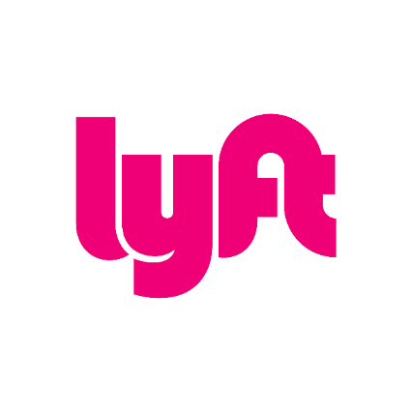

Lyft (Directions to download App):
- Download the Lyft app in the app store
- Enter relevant information asked
- Select the appropriate vehicle on the bottom panel
- Enter the destination
- Enter your location
- Wait for the drive to arrive and they will call you

Public Bus Transportation:

- CARTA - Charleston Regional Transportation Authority
- 36 John St Charleston, SC 29403 (843) 724-7420
- http://www.charlestoncvb.com/plan-your-trip/transportation~211/ground-transportation~1264/carta-charleston-regional-transportation-authority~5973.html

